**Regional Profit Analysis**

**Data Source**

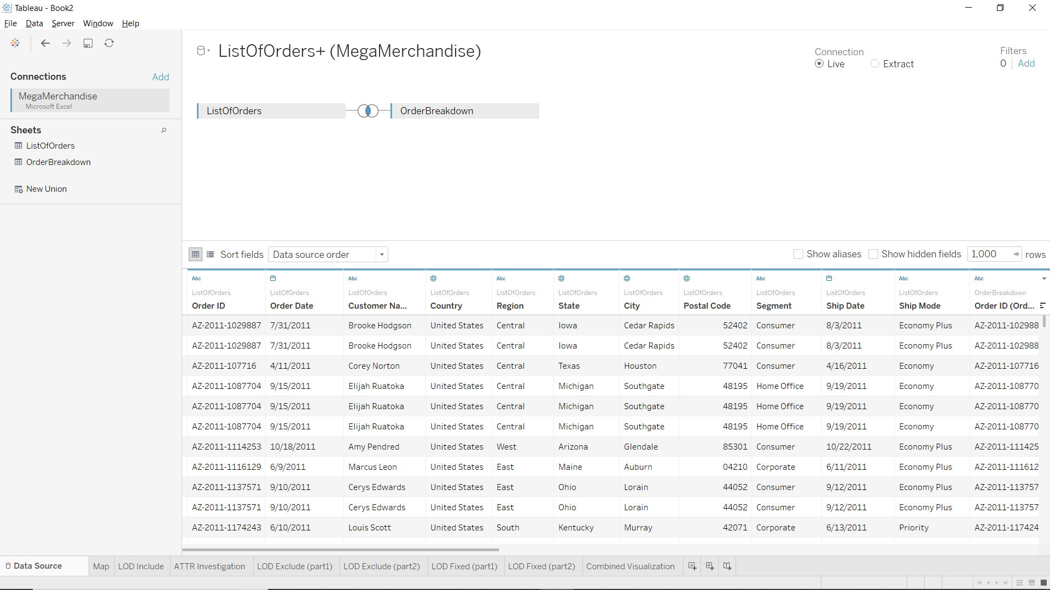

**Map with overall State Profit**

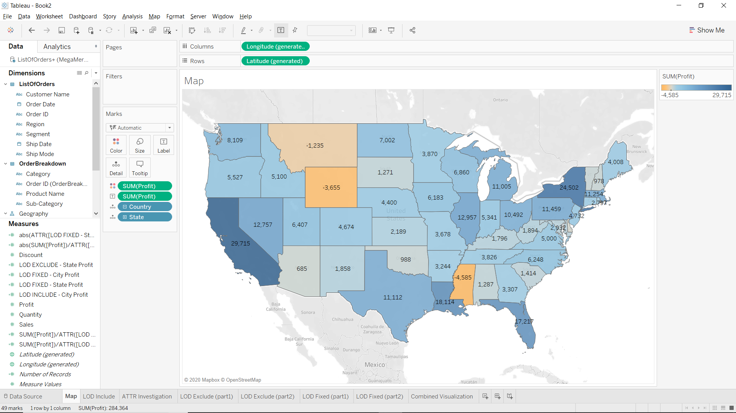

**LOD Include**

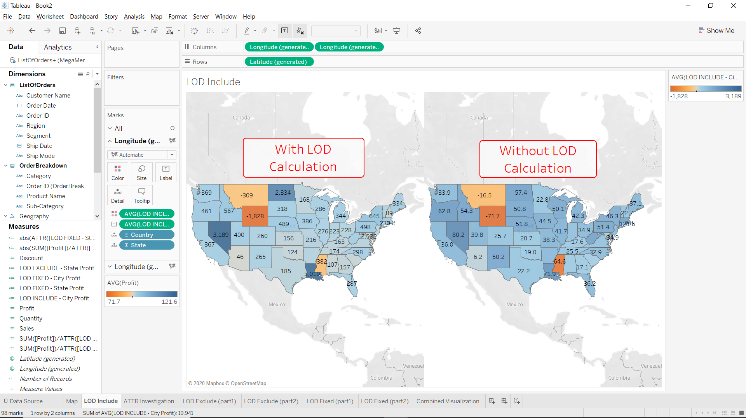

**ATTR Function**

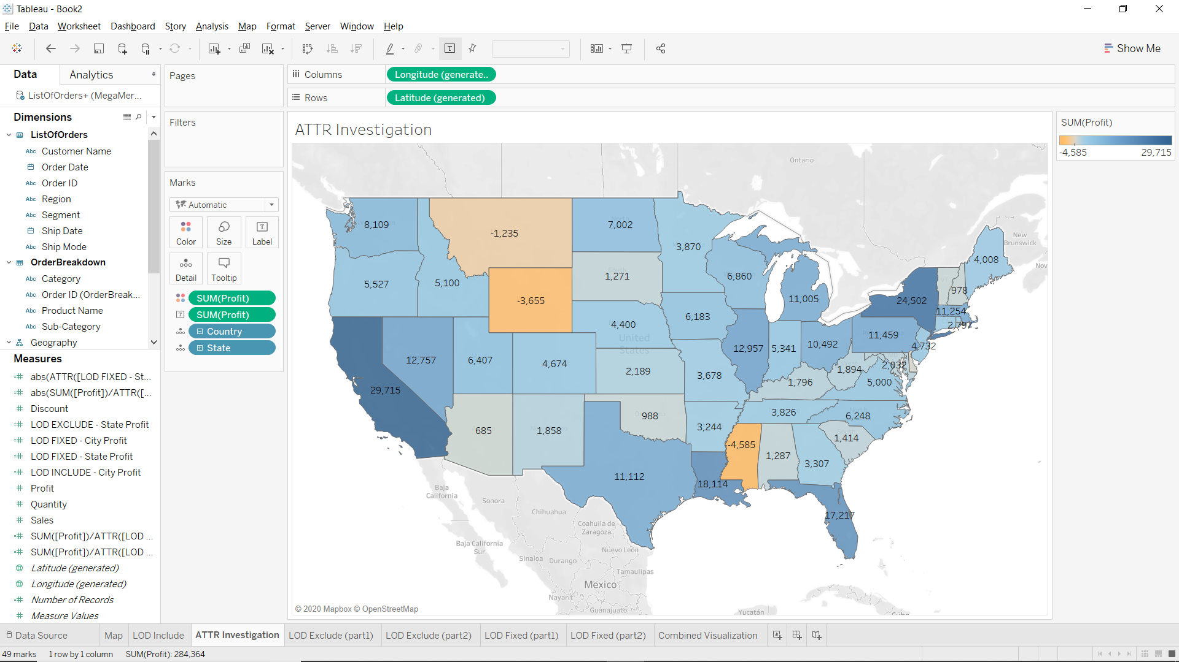

**LOD Exclude (Part1)**

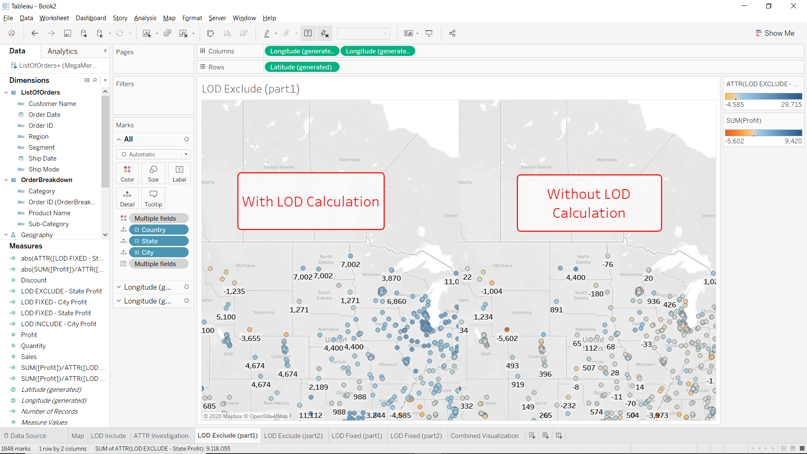

**LOD Exclude (Part2)**

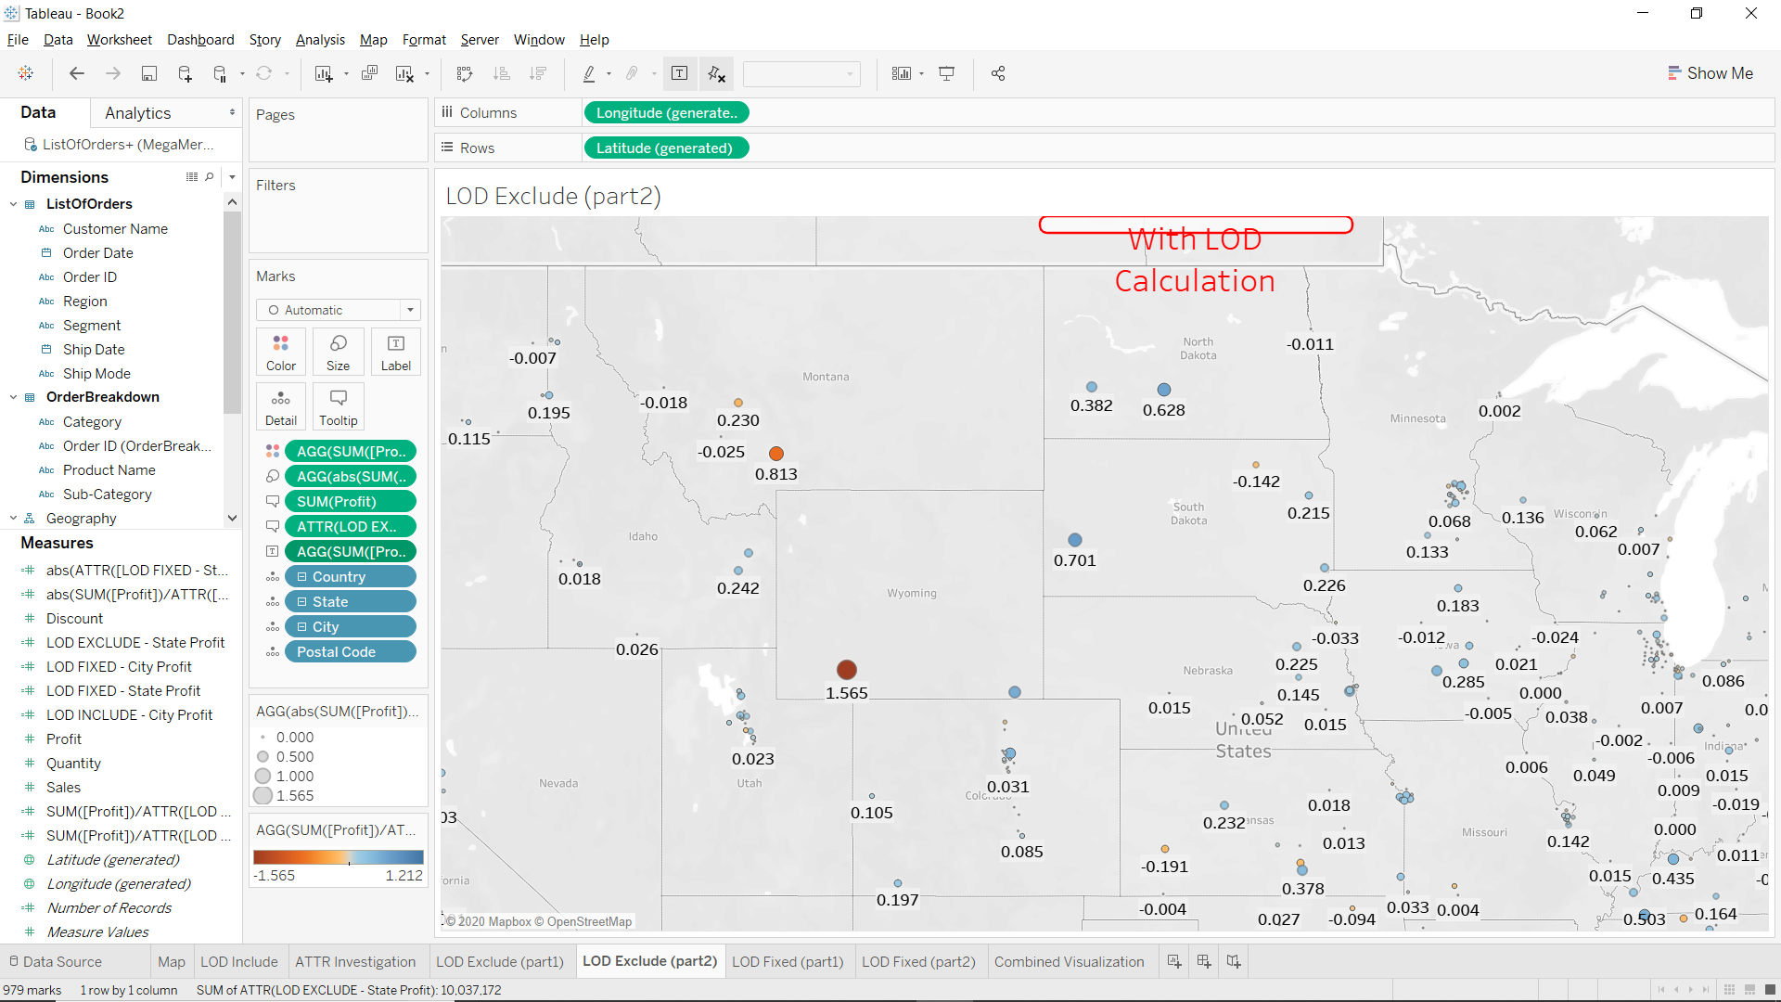

**LOD Fixed (Part1)**

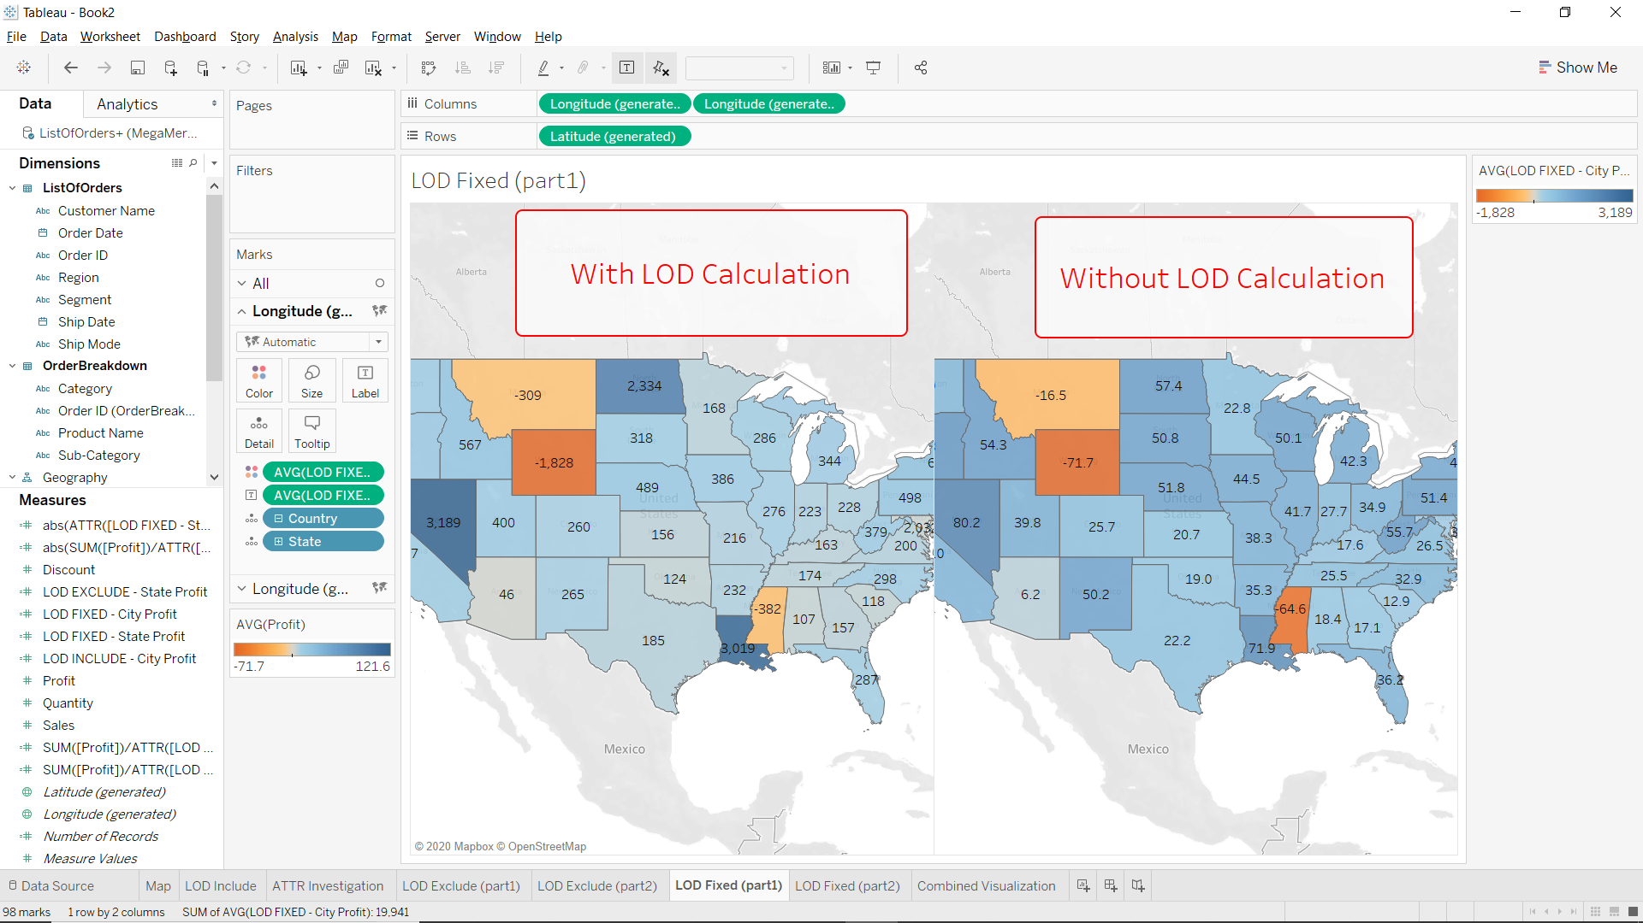

**LOD FIXED (Part2)**

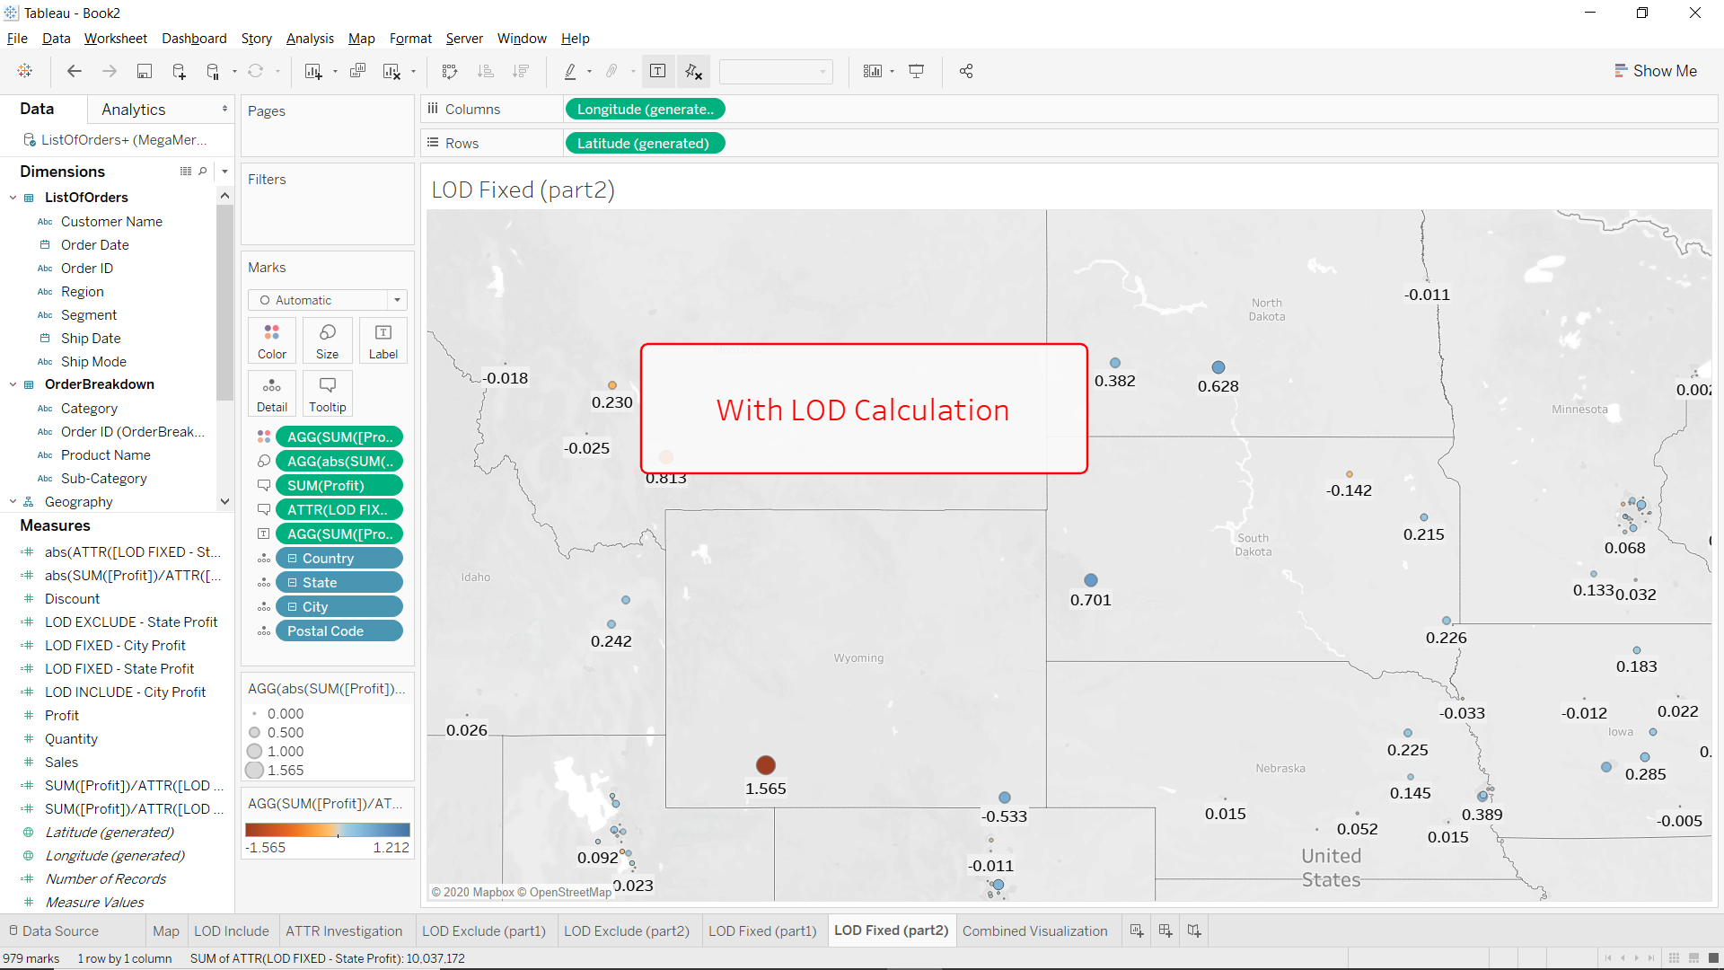

**Combined Visualization**

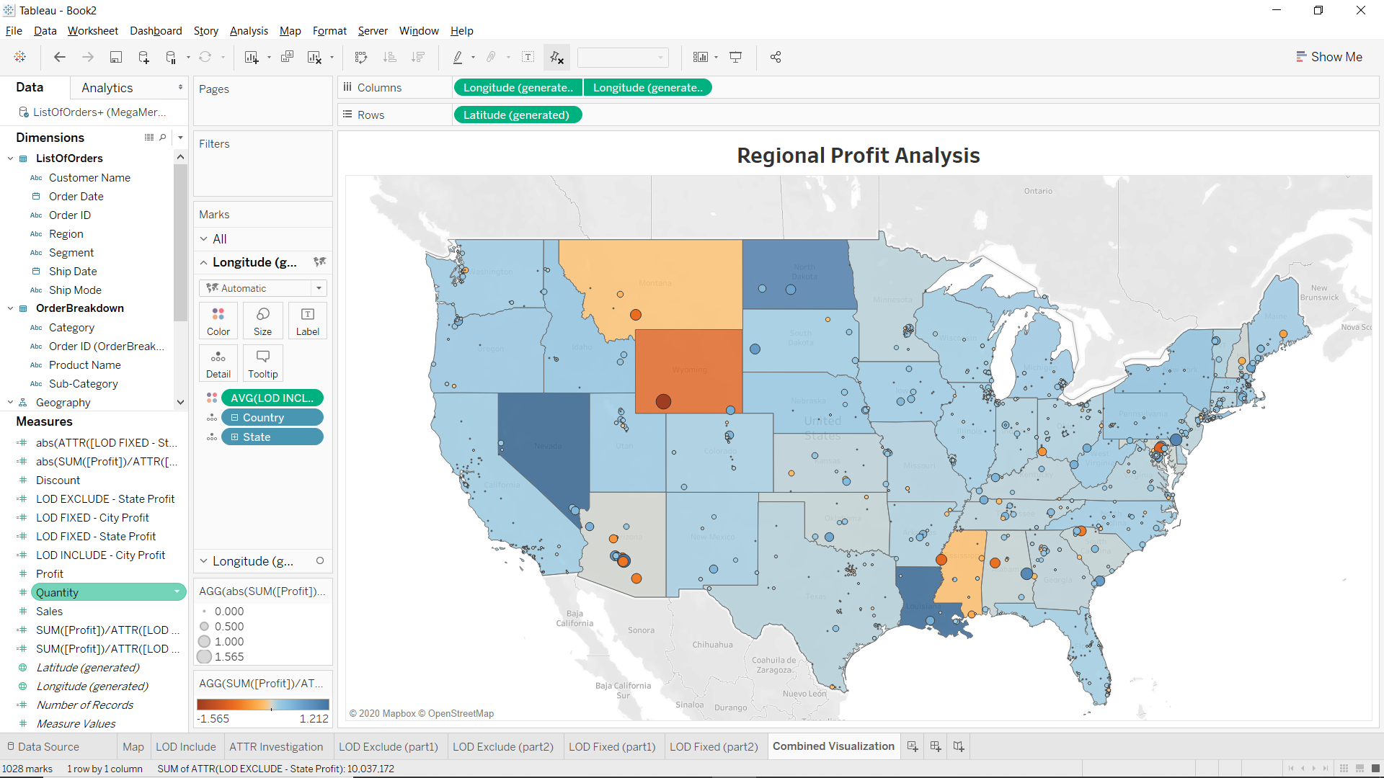

**Combined Visualization (Presentation Mode)**

